### A PROJECT REPORT ON

**“Fraud Detection in UPI Transactions using CNN”**

SUBMITTED TO THE SAVITRIBAI PHULE PUNE UNIVERSITY, PUNE IN THE PARTIAL FULFILLMENT OF THE REQUIREMENTS FOR THE AWARD OF THE DEGREE

**BACHELOR OF ENGINEERING COMPUTER ENGINEERING SUBMITTED BY**

Mr. Vipul Zope Exam No: B1905504339

Mr. Pritamsingh Ratra Exam No: B1905504307

Mr. Ishaan S Mattoo Exam No: B1905504246

## Under The Guidance of Dr. Saurabh Saoji

**DEPARTMENT OF COMPUTER ENGINEERING**

### (NBA ACCREDITED)



**NUTAN MAHARASHTRA INSTITUTE OF ENGINNERING TECHNOLOGY TALEGAON DABHADE TAL.MAVAL, PUNE, 410507**

### SAVITRIBAI PHULE PUNE UNIVERSITY

**2024-2025**



**CERTIFICATE**

This is to certify that the Project Entitled

**“Fraud Detection of UPI Transactions using CNN”**

Submitted by

Vipul Zope Exam No: B1905504339

Pritamsingh Ratra Exam No: B1905504307

Ishaan S Mattoo Exam No: B1905504246

is a bonafide student of this institute and the work has been carried out by him/her under the supervision of Dr. Saurabh Saojiand it is approved for the partial fulfillment of the requirement of **Savitribai Phule Pune University**, for the award of the degree of Bachelor of Engineering in Computer Engineering.

|  |  |  |  |
| --- | --- | --- | --- |
| Dr. Saurabh Saoji | Prof. Pritam Ahire | Dr. Prasad Dhore | Dr. S. N. Sapali |
| **Internal Guide** | **Project Coordinator** | **H.O.D.** | **Principal** |

|  |
| --- |
| External Examiner |
| **Sign** |

Nutan Maharashtra Institute of Engineering and Technology, Pune – 07. Place: Pune

Date:

**Acknowledgments**

*It gives us great pleasure in presenting the preliminary project report on* ***Fraud Detection in UPI Transactions using CNN.*** *I would like to express my special thanks of gratitude to* ***Prof. Pritam Ahire,*** *Project Coordinator Computer Engineering Department, for giving me all the help and guidance I needed. I am really grateful to them for their kind support. Their valuable suggestions were very helpful.*

*I am also grateful to* ***Dr. Prasad Dhore****, Head of Computer Engineering Department, Nutan Maharashtra institute of Engineering and Technology, Pune for his indispensable support, suggestions.*

*In the end our special thanks to* ***Dr. S. N. Sapali,*** *Principal, Nutan Maharashtra institute of Engineering and Technology, Pune for providing healthy environment, resources such as laboratory with all needed software platforms, tools etc... which helped us to successfully complete our project.*

*Also, I would like to take this opportunity to thank my family members & supporters, without them it could not have been done effectively in such a short period of time. I cannot forget their love & support.*

Vipul Zope (B1905504339)

Pritamsingh Ratra (B1905504307)

Ishaan.S.Mattoo(B1905504246)

(B.E. Computer Engineering)

# Table of Contents

Abstract 1

1. Introduction 2-5

Aims 3

Motivation 3

Scope 4

Objectives 4

1. Problem Statement 6
2. Project Requirements 7-10
3. Literature Survey 11-15
4. System Analysis 16-19
5. Proposed Architecture 20-22
6. Proposed System Algorithm 23-25
7. Methodology 26-29
8. Mathematical Model 30-35
9. System Design Details 36-41

Flow Chart 36

Use Case Diagram 37

Class Diagram 38

Activity Diagram 39

Component Diagram 40

Sequence Diagram 41

1. Project Implementation 42-48

Code Documentation 42-46

Module Wise Design 42-46

Module Wise Output 47-48

1. Project Modules Screen Shots 49-55
2. Project Plan 56-63
3. Conclusions 64-65
4. Conclusions 66-68

Tools Used 66-67

References 67-68

## ABSTRACT

This paper presents a UPI fraud detection system utilizing advanced machine learning techniques to enhance the security of digital payment transactions. The methodology includes data cleaning, feature extraction using a bag-of-words model, and training various classifiers such as Naive Bayes, Support Vector Machine (SVM), and Logistic Regression on pre-processed transaction data.

The system aims to identify and mitigate different types of UPI fraud, including phishing and unauthorized transactions, through real-time monitoring and anomaly detection. Evaluation metrics like accuracy, precision, recall, and confusion matrices are employed to assess the model's performance. Despite challenges such as class imbalance and generalization issues, the system demonstrates significant potential in minimizing financial losses and protecting user privacy in the growing landscape of digital payments. This research contributes to developing robust fraud detection mechanisms that can adapt to evolving threats in financial transactions.

## INTRODUCTION

In the contemporary digital landscape, the proliferation of mobile payment systems has fundamentally transformed how financial transactions are conducted. Among these innovations, the Unified Payments Interface (UPI) has emerged as a leading platform in India, facilitating seamless and instantaneous transactions between users. UPI allows individuals to transfer money, pay bills, and conduct various financial activities with just a few taps on their smartphones. This convenience has significantly contributed to the growth of digital payments, promoting financial inclusion and accessibility.

However, with the rapid adoption of UPI comes an alarming increase in fraudulent activities. As the volume of transactions rises, so does the sophistication of fraudsters who exploit vulnerabilities in the system. Reports indicate a substantial rise in UPI-related fraud cases, including phishing attacks, account takeovers, and unauthorized transactions. These incidents not only lead to financial losses for users but also erode trust in digital payment systems, hindering their widespread acceptance.

To combat this growing threat, there is an urgent need for effective fraud detection mechanisms that can identify suspicious activities in real-time. Traditional rule-based systems often fall short due to their inability to adapt to new patterns of fraud. As a result, there is a shift towards leveraging advanced machine learning techniques that can analyze vast amounts of transaction data and learn from historical patterns.

This project focuses on developing a robust fraud detection system specifically designed for UPI transactions using Convolutional Neural Networks (CNNs). CNNs are particularly well-suited for this task due to their ability to capture complex patterns in data through multiple layers of abstraction. By training a CNN model on historical transaction data, we aim to create a system that can accurately classify transactions as either legitimate or fraudulent.

The proposed system will consist of several key components: data collection and preprocessing, model development and training, backend API implementation using Flask, and a user-friendly frontend dashboard built with React. Each component plays a crucial role in ensuring that the system operates efficiently and effectively.

Through this project, we aim not only to enhance the security of UPI transactions but also to contribute to the broader field of financial technology by demonstrating how machine learning can be applied to real-world challenges. The ultimate goal is to provide users with a reliable tool that safeguards their financial transactions while maintaining the convenience that digital payments offer.

### 1.1 Aims

The primary aim of this project is to create a robust CNN-based model capable of accurately detecting fraudulent UPI transactions in real-time. This system will focus on analyzing vast amounts of transaction data to identify anomalies and patterns that may suggest fraudulent activities. The ultimate goal is to safeguard users from financial losses and maintain the integrity of digital payment systems.

### 1.2 Motivation

The motivation for this project arises from the growing concern over digital payment fraud, which poses significant risks to consumers and financial institutions alike. As fraudsters become more sophisticated in their tactics, traditional methods of fraud detection, which often rely on static rules and heuristics, are proving inadequate. By employing machine learning techniques like CNNs, this project seeks to develop a proactive solution that not only detects known fraud patterns but also adapts to new threats through continuous learning and optimization.

### 1.3 Scope

The scope of this project encompasses several key areas:

* Data Collection: Gathering historical UPI transaction data from various sources.
* Data Pre-processing: Cleaning and normalizing the data to ensure it is suitable for analysis.
* Model Development: Designing and training a CNN model specifically tailored for detecting anomalies in transaction data.
* Performance Evaluation: Assessing the model's effectiveness using various metrics such as accuracy, precision, recall, and F1 score.
* User Interface Implementation: Creating a user-friendly interface for real-time monitoring and alerts regarding suspicious transactions.

### 1.4 Objectives

The specific objectives of this project include:

* + - To analyze existing UPI transaction datasets to identify patterns indicative of fraudulent activities.
    - To develop a CNN model that can effectively recognize anomalies in transaction behaviours.
    - To evaluate the model's performance using relevant metrics to ensure high accuracy and low false-positive rates.
    - To create an interactive dashboard that allows stakeholders to monitor transactions and receive alerts on potential fraud in real-time.

## 2. PROBLEM STATEMENT

The rapid growth of digital payment systems, particularly the Unified Payments Interface (UPI), has led to significant advancements in financial transactions. However, this convenience has also been accompanied by a surge in fraudulent activities, posing serious risks to users and financial institutions. Traditional fraud detection methods often rely on static rules and heuristics, which are increasingly inadequate in identifying sophisticated fraud patterns that evolve over time. The challenge lies in the inherent characteristics of UPI transactions, which include high transaction volumes, diverse user behaviours, and the presence of imbalanced datasets where fraudulent transactions are significantly fewer than legitimate ones. This imbalance complicates model training and increases the likelihood of false positives and negatives, further undermining trust in digital payment systems. Moreover, existing systems often struggle with real-time processing capabilities, making it difficult to promptly identify and mitigate fraudulent activities. As fraudsters continuously adapt their tactics, there is an urgent need for a proactive and adaptive fraud detection system that employs advanced machine learning techniques. This project aims to address these challenges by developing a robust fraud detection system utilizing Convolutional Neural Networks (CNNs). The proposed system will analyze transaction data in real-time to identify anomalies indicative of fraud while maintaining a low false-positive rate. By leveraging the power of machine learning, this project seeks to enhance the security of UPI transactions and protect users from financial losses due to fraud.

## 3. PROJECT REQUIREMENTS

To successfully develop a fraud detection system for UPI transactions using Convolutional Neural Networks (CNNs), several project requirements must be established. These requirements encompass hardware and software specifications, data requirements, and other necessary resources for effective implementation.

### 3.1 Hardware Requirements:

1. Computer Specifications:
   * Processor: A multi-core processor (Intel i5 or higher recommended) to handle intensive computations.
   * RAM: Minimum of 16 GB RAM to support data processing and model training.
   * Graphics Processing Unit (GPU): A dedicated GPU (NVIDIA GTX 1060 or equivalent) is essential for accelerating the training of deep learning models.
   * Storage: At least 1 TB of storage to accommodate datasets, model files, and logs.
2. Network Requirements:
   * A stable internet connection for data access, cloud services, and collaboration tools.

### 3.2 Software Requirements:

1. Operating System:

Windows, macOS, or Linux (Ubuntu recommended for compatibility with machine learning libraries).

1. Programming Language:

Python is the primary language for implementing machine learning algorithms and data processing.

1. Libraries and Frameworks:
   * Deep Learning Frameworks: TensorFlow and Keras for building and training CNN models.
   * Data Manipulation: Pandas and NumPy for data pre-processing and manipulation.
   * Data Visualization: Matplotlib and Seaborn for visualizing data distributions and model performance.
   * Machine Learning Libraries: Scikit-learn for additional machine learning algorithms and evaluation metrics.
2. Database Management System:

MySQL or MongoDB for storing transaction data and user information securely.

1. Development Environment:

An Integrated Development Environment (IDE) such as Jupyter Notebook, PyCharm, or Visual Studio Code to facilitate coding and debugging.

### 3.3 Data Requirements:

1. Transaction Datasets:

Access to historical UPI transaction data that includes both legitimate and fraudulent transactions. This dataset should ideally contain features such as transaction amount, timestamp, user ID, location, and transaction type.

1. Data Privacy Compliance:

Ensure that the dataset complies with relevant data protection regulations (e.g., GDPR or local regulations) to safeguard user privacy.

### Other Resources:

1. Documentation Tools:

Tools such as Markdown editors or LaTeX for documenting the project progress, methodologies, and findings.

1. Version Control System:

GitHub or GitLab for version control of the codebase, enabling collaboration and tracking changes over time.

1. Testing Frameworks:

Testing libraries such as PyTest to validate the functionality of individual modules within the project.

1. User Interface Development Tools:

Frameworks like Flask or Django for developing a web-based user interface that allows users to interact with the fraud detection system in real-time.

By fulfilling these requirements, the project will be well-equipped to develop an effective fraud detection system that leverages advanced machine learning techniques to enhance the security of UPI transactions.

## 4. LITERATURE SURVEY

The following literature survey reviews recent research papers focused on fraud detection in UPI transactions and similar digital payment systems. The papers are presented in descending order, from the latest to older studies, highlighting their methodologies, findings, and contributions to the field.

### Implementation Paper on UPI Fraud Detection using Machine Learning (2024)

This paper presents a comprehensive machine learning-based system designed to detect fraudulent transactions in UPI. The methodology includes data cleaning, feature extraction using Count Vectorizer, and training various classifiers such as Naive Bayes, Stochastic Gradient Descent (SGD), Support Vector Machine (SVM), and Logistic Regression. The study emphasizes the importance of evaluating models using accuracy, precision, recall, and ROC curves. The system aims to enhance security by identifying fraudulent activities in real-time while addressing challenges such as class imbalance and generalization to new datasets. Limitations include potential inaccuracies due to simplified neutral classification and real-time processing challenges.

### Fraud Detection in UPI Transactions Using ML (2023)

This research explores multiple machine learning algorithms for detecting fraud in UPI transactions. It highlights the challenges posed by imbalanced datasets where fraudulent transactions are significantly fewer than legitimate ones. The paper proposes a framework that utilizes ensemble methods to improve detection rates while minimizing false positives. The authors present a comparative analysis of different algorithms, including Random Forest and Decision Trees, demonstrating their effectiveness in identifying fraudulent patterns within transaction data.

### UPI Fraud Detection using Machine Learning (2022)

This study investigates various machine learning techniques applied to UPI transaction data for fraud detection. It focuses on feature selection and engineering to enhance model performance. The authors implement a hybrid model combining supervised and unsupervised learning approaches to detect anomalies effectively. The results indicate that the proposed model outperforms traditional methods in terms of accuracy and detection speed, showcasing the potential of machine learning in enhancing digital payment security.

### UPI Fraud Detection Using Machine Learning (2021)

In this paper, the authors analyze different machine learning classifiers for detecting fraudulent transactions in UPI systems. They emphasize the importance of pre processing steps such as normalization and encoding categorical variables. The study evaluates classifiers like K-Nearest Neighbors (KNN) and Logistic Regression, providing insights into their strengths and weaknesses in handling imbalanced datasets. The findings suggest that ensemble methods can significantly improve detection rates by leveraging the strengths of multiple classifiers.

### Fraud Detection using Machine Learning (2020)

This research paper discusses the application of machine learning algorithms for detecting fraudulent financial transactions across various platforms, including UPI. The authors compare several models, including Neural Networks and Gradient Boosting Machines, focusing on their ability to learn from historical transaction data to predict future fraud occurrences. The study highlights the challenges of feature selection and model interpretability while providing recommendations for improving fraud detection systems through advanced analytics.

### Leveraging HMM for UPI Fraud Detection Using Deep Learning Model (2019)

This paper integrates Hidden Markov Models (HMM) with deep learning techniques for enhanced fraud detection in UPI transactions. The authors propose a novel approach that combines temporal modelling with deep learning’s feature extraction capabilities.

The results indicate improved accuracy in detecting fraudulent patterns compared to traditional methods, suggesting that hybrid models can be effective in addressing complex fraud scenarios.

### Fraudulent Financial Transactions Detection Using Machine Learning (2018)

The focus of this study is on developing a comprehensive framework for detecting fraudulent financial transactions through machine learning techniques. It reviews various algorithms used in the literature, emphasizing their applicability to different types of financial fraud, including credit card fraud and online payment scams. The authors provide a systematic overview of evaluation metrics commonly used in fraud detection studies, highlighting the need for continuous improvement in model performance.

### Online Payment Fraud Detection Model Using Machine Learning Techniques (2017)

This research explores an integrated approach to online payment fraud detection using machine learning techniques. The authors propose a model that incorporates both supervised and unsupervised learning methods to identify fraudulent transactions effectively. They discuss the significance of feature engineering and selection processes in improving model accuracy and reducing false positive rates.

### Online Payment Fraud Detection: An Integrated Approach (2016)

In this paper, the authors present an integrated approach for detecting online payment fraud using various machine learning algorithms. They analyze the effectiveness of different models such as Decision Trees and Support Vector Machines while addressing issues related to dataset imbalance and feature selection. The findings suggest that combining multiple algorithms can enhance overall detection performance.

### Online Payment Fraud Detection Using Machine Learning (2015)

The study focuses on applying machine learning techniques to detect online payment fraud across various platforms. It reviews existing methodologies and highlights common challenges faced by researchers in this domain, such as data quality issues and model interpretability. The authors advocate for further research into hybrid models that combine multiple approaches for improved accuracy in fraud detection.

This literature survey underscores the growing body of research aimed at enhancing fraud detection mechanisms within digital payment systems like UPI through advanced machine learning techniques, reflecting an ongoing commitment to improving security measures against evolving threats in financial transactions.

## SYSTEM ANALYSIS

The system analysis for the proposed UPI fraud detection project involves a comprehensive examination of the existing frameworks, methodologies, and challenges in detecting fraudulent transactions. This analysis will inform the design and implementation of a robust system that leverages machine learning techniques, specifically Convolutional Neural Networks (CNNs), to enhance the security of UPI transactions.

5.1 Current Landscape of Fraud Detection

1. Fraud Detection Challenges:
   * Imbalanced Datasets: Fraud detection datasets often exhibit a significant imbalance between legitimate and fraudulent transactions. This imbalance complicates model training, leading to higher false positive rates and reduced accuracy in identifying actual fraud cases.
   * Evolving Fraud Patterns: Fraud tactics are continually evolving, making it challenging for traditional detection systems to adapt. Static rule-based systems are often inadequate in recognizing new patterns of fraudulent behaviour.
   * Real-Time Processing Needs: The necessity for real-time fraud detection adds complexity to system design. Delays in identifying fraudulent transactions can lead to substantial financial losses.
2. Existing Methodologies:

Many current systems employ machine learning algorithms such as Support Vector Machines (SVM), Random Forests, and Logistic Regression for fraud detection. While these methods have shown promise, they often require extensive feature engineering and may not generalize well to unseen data.

* + Recent studies have highlighted the potential of deep learning techniques, particularly CNNs, which can automatically extract relevant features from transaction data without extensive pre-processing.

5.2 Proposed System Overview:

The proposed UPI fraud detection system aims to address the challenges identified in existing methodologies by implementing the following components:

1. Data Collection and Pre-processing:

The system will gather historical UPI transaction data that includes both legitimate and fraudulent transactions. Data pre-processing will involve cleaning, normalization, and transformation to ensure compatibility with machine learning algorithms.

1. Feature Extraction Using CNN:

The use of CNNs allows for automatic feature extraction from transaction data. This capability is particularly beneficial in identifying complex

patterns indicative of fraud without requiring manual feature engineering.

1. Model Training and Evaluation:

The system will employ an 80/20 training-test split for model training and evaluation. Various metrics such as accuracy, precision, recall, and F1 score will be utilized to assess model performance.

1. User Interface Development:

A user-friendly interface will be developed to facilitate interaction with the fraud detection system. This interface will provide stakeholders with real-time monitoring capabilities and insights into transaction patterns.

5.3 Limitations and Considerations:

While the proposed system aims to enhance fraud detection capabilities, several limitations must be considered:

* + Generalization: The effectiveness of the model on unseen data remains a concern due to potential overfitting during training.
  + Scalability: As transaction volumes increase, ensuring that the system can handle large datasets without latency issues is crucial.
  + Continuous Learning: Implementing a mechanism for continuous learning will be necessary to adapt to evolving fraud patterns over time.

## 6. PROPOSED ARCHITECTURE

6.1 Architecture for Fraud Detection of UPI Transactions

In today's digital landscape, ensuring the security and integrity of financial transactions is paramount. To combat fraudulent activities in Unified Payments Interface (UPI) transactions, we propose a cutting-edge architecture that leverages the power of machine learning and streamlined frontend and backend technologies.

6.2 Architectural Overview: A Three-Tiered Approach

Our proposed architecture consists of three distinct layers, each playing a vital role in detecting and preventing fraud:

1. Presentation Layer: Built using React, this layer provides an intuitive user interface where users can seamlessly upload transaction files and view results on a dashboard.
2. Application Layer: Implemented using Flask, this layer serves as the backend API, handling requests from the frontend, processing data, interacting with the machine learning model, and returning responses.
3. Data Layer: This layer encompasses data storage and the machine learning model, trained on historical transaction data to identify fraudulent patterns.

6.3 Key Components and Interactions

## Frontend (React)

## • User Interface: Upload transaction files and view results on a dashboard.

## • Upload Page: Upload CSV files containing transaction data.

## • Dashboard: Displays fraud detection results, including transaction details and fraud probabilities.

## Backend (Flask)

## • Flask Application: Handles HTTP requests and processes uploaded files.

## • File Upload Endpoint: Accepts CSV files, saves them, and triggers fraud detection.

## • Model Interaction: Loads the pre-trained CNN model or trains a new one.

## • Prediction Endpoint: Processes data, predicts fraud probabilities, and returns results.

## Machine Learning Model (CNN)

## • UPIFraudDetector Class: Encapsulates fraud detection functionalities.

## • Data Preprocessing: Extracts and scales relevant features.

## • Model Building: Constructs a CNN architecture for time-series classification.

## • Training: Trains the model on labeled data.

## • Prediction: Predicts fraud probabilities for new transactions.

6.4 Seamless Data Flow

The data flow in this architecture is efficient and streamlined:

1. Users upload CSV files through the frontend interface.

2. The Flask backend receives the file via an HTTP POST request.

3. The backend saves the file and invokes the UPIFraudDetector class.

4. If a trained model exists, it loads; otherwise, it builds and trains a new model.

5. Predictions are made on uploaded data.

6. Results are sent back to the frontend in JSON format.

7. The frontend updates the dashboard with these results.

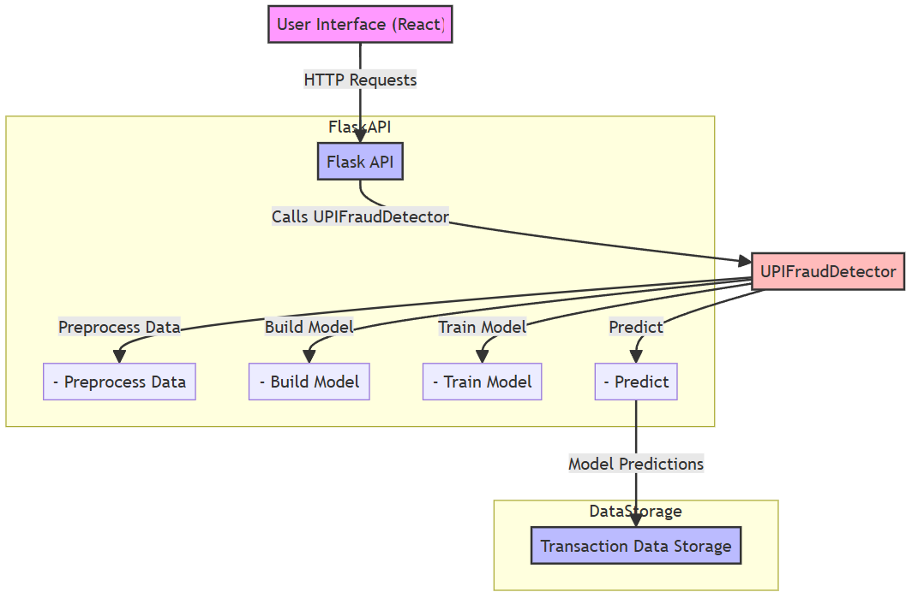

*(Fig 6.4.1)*

### 7. PROPOSED SYSTEM ALGORITHM

To effectively identify and prevent fraudulent activities in Unified Payments Interface (UPI) transactions, we propose a robust system algorithm. This algorithm leverages the capabilities of Convolutional Neural Networks (CNNs) to detect anomalies in transaction patterns.

Algorithm Steps: A Step-by-Step Guide

The algorithm consists of several key stages:

1. **Initialization**

* Import necessary libraries, including Flask for backend development, Pandas for data manipulation, and TensorFlow for building the CNN model.
* Set up the Flask application, configuring upload paths for seamless file handling.

1. **File Upload**

* Define an endpoint to accept CSV file uploads containing transaction data.
* Validate the uploaded file format to ensure compatibility.

1. **Data Preprocessing**

* Read the uploaded CSV file into a DataFrame for efficient data manipulation.
* Convert timestamps to extract valuable features:
  1. Hour of the day
  2. Day of the week
* Extract relevant features for model input:
  1. Transaction amount
  2. Hour
  3. Day of the week
  4. Sender account age
  5. Recipient account age
  6. Sender transaction count
  7. Recipient transaction count
* Scale the features using StandardScaler to ensure consistency.
* Reshape the data for input into the CNN, optimizing its architecture.

1. **Model Training or Loading**

* Check if a pre-trained model exists.
* If it exists, load the model for immediate use.
* If not, build and train a new CNN model using the preprocessed data.
* Save the trained model for future use, ensuring efficiency.

1. **Prediction**

* Use the trained or loaded model to predict fraud probabilities on new transaction data.
* Return predictions to the frontend for display.

1. **Display Results**

* Format and send the prediction results back to the user interface.
* Present the results in a clear, actionable format, empowering users to make informed decisions.

ALGORITHM DIAGRAM -

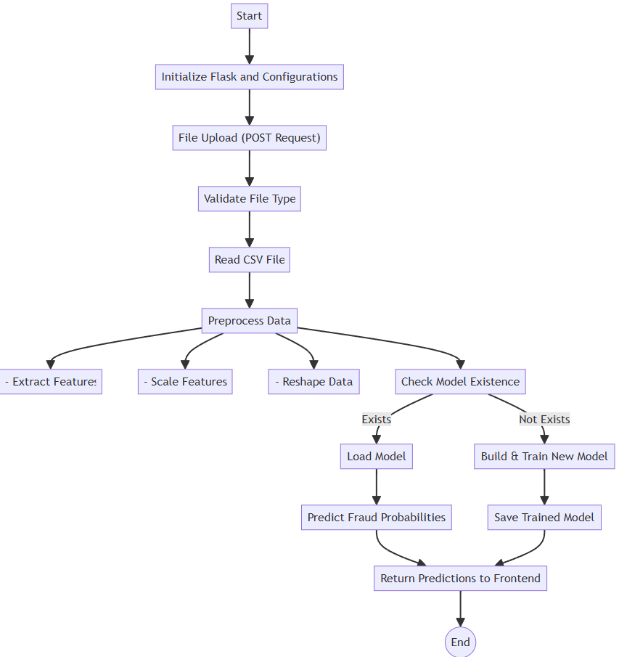

*(Fig 7.1)*

## 8. METHODOLOGY

Developing an effective fraud detection system for Unified Payments Interface (UPI) transactions requires a structured approach. Our methodology leverages Convolutional Neural Networks (CNNs) to identify potential fraudulent activities.

Step-by-Step Process

**1. Data Collection**

* Source: UPI transaction logs containing features like transaction amount, timestamps, account ages, and fraud labels.
* Format: Data is stored in CSV format for seamless processing and analysis.

**2. Data Preprocessing**

* Loading Data: Upload CSV files into Pandas DataFrames.
* Feature Extraction:
  + Convert timestamps into hour of the day and day of the week.
  + Identify relevant features: amount, hour, day of the week, sender/recipient account ages, and sender/recipient transaction counts.
* Scaling Features: Standardize features using StandardScaler for equal contribution to model training.
* Reshaping Data: Convert data into 3D arrays suitable for CNN input.

**3. Model Development**

* Model Architecture: Define CNN architecture using TensorFlow/Keras.
  + Multiple convolutional layers with max pooling.
  + Flattening layer for 3D to 1D conversion.
  + Fully connected layers with dropout for regularization.
* Model Compilation: Compile with Adam optimizer and binary crossentropy loss function.

**4. Model Training**

* Training Process: Split preprocessed data into training and validation sets.
* Train CNN model on training set while validating on validation set.
* Monitor performance metrics: accuracy and AUC.

**5. Model Evaluation**

* Evaluate model performance on a separate test set for generalization.
* Adjust hyperparameters based on performance metrics.

**6. Prediction**

* Load trained model for predictions on new transaction data.
* Preprocess incoming data similarly to training (scaling and reshaping).
* Generate fraud probability scores for each transaction.

**7. Deployment**

* Deploy Flask application as an API for file uploads and predictions.
* Create a React-based dashboard for visualizing results and easy file uploads.

**8. User Interaction**

* Users upload transaction files through the web interface.
* The system processes files and provides feedback on potential fraudulent transactions.

Workflow Diagram -

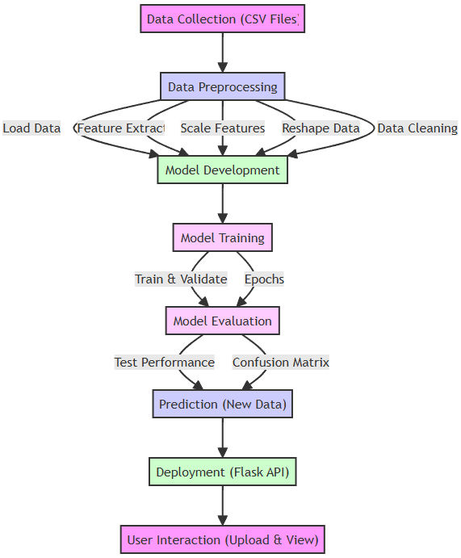

*(Fig 6.4.1)*

## 9. MATHEMATICAL MODEL

The mathematical model for detecting fraudulent transactions in UPI (Unified Payments Interface) systems is based on a Convolutional Neural Network (CNN). This section provides an in-depth exploration of the mathematical principles and formulas that underpin the model, including data preprocessing, feature extraction, model architecture, training, evaluation, and prediction.

**9.1. Data Preprocessing**

Data preprocessing is crucial for transforming raw transaction data into a suitable format for the CNN. The steps involved are as follows:

9.1.1 Loading Data

The data is loaded from a CSV file into a Pandas DataFrame:

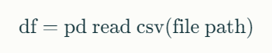

9.1.2 Feature Extraction

The relevant features are extracted from the transaction data. This includes converting timestamps into usable features:

Timestamp Conversion:

* Extract hour of the day:



* Extract day of the week:



Feature Vector: The features used for modeling include:

* Transaction amount ($X_1$)
* Hour of the day ($X_2$)
* Day of the week ($X_3$)
* Sender account age ($X_4$)
* Recipient account age ($X_5$)
* Sender transaction count ($X_6$)
* Recipient transaction count ($X_7$)

These features can be represented as a vector:

X=[X1,X2,X3,X4,X5,X6,X7]

9.1.3 Feature Scaling

To ensure that all features contribute equally to the model training, they are standardized using StandardScaler:

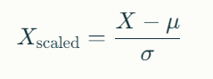

Where:

* μ is the mean of the feature.
* σ is the standard deviation of the feature.

This transformation helps to center the data around zero and scale it to unit variance.

9.1.4 Reshaping Data

The data is reshaped to fit the input requirements of the CNN:

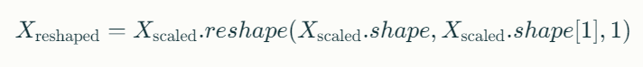

This reshaping is necessary because CNNs expect input in three dimensions: (samples, timesteps, features).

**9.2. Model Architecture**

The CNN architecture is designed to learn complex patterns in transaction data that may indicate fraud. The architecture consists of several layers:

9.2.1 Input Layer

The input layer accepts reshaped input data with dimensions (N,T,F) where:

* N = number of samples
* T = number of timesteps (usually set to 1 for static features)
* F = number of features (7 in this case)

9.2.2 Convolutional Layers

Each convolutional layer applies filters to detect patterns in the input data. The mathematical operation for a convolutional layer can be expressed as:



Where:

* Zis the output feature map.
* Wis the filter (kernel).
* ∗ denotes convolution operation.
* b is the bias term.

For a single filter applied to an input sequence:

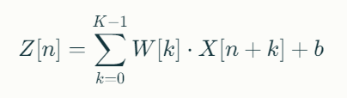

Where:

* **n** indexes the position in the output.
* **K** is the size of the filter.

9.2.3 Activation Function

ReLU (Rectified Linear Unit) is used as an activation function:



This function introduces non-linearity into the model.

9.2.4 Max Pooling Layer

Max pooling reduces dimensionality by taking the maximum value over a specified window:

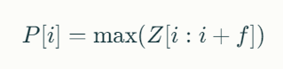

Where:

* fis the size of the pooling window.
* i indexes over the output feature map.

9.2.5 Flattening Layer

The flattening layer converts pooled feature maps into a single vector suitable for dense layers.

9.2.6 Dense Layers

Fully connected layers that output predictions based on learned features use a sigmoid activation function in the final layer to predict probabilities:



Where:

* P(fraud) is the probability of fraud.
* W represents weights.
* A is the activation from the previous layer.
* b is the bias.

The sigmoid function can be defined as:

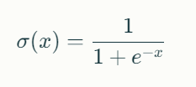

**9.3. Training Process**

The training process involves minimizing a loss function to improve model accuracy. The loss function used here is binary crossentropy:

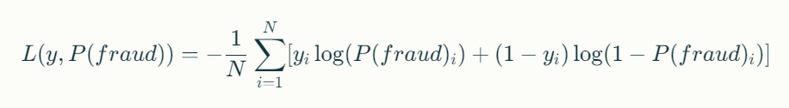Where:

* yi: Actual label (0 or 1).
* P(fraud)i​: Predicted probability for instance i*i*.
* N: Total number of instances.

This loss function measures how well the predicted probabilities match actual labels.

9.3.1 Optimization Algorithm

The optimization algorithm used is Adam, which updates weights using gradients calculated from backpropagation:

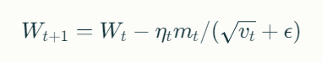

Where:

* Wt​: Current weights.
* mt​: First moment estimate (mean).
* vt: Second moment estimate (uncentered variance).
* ηt: Learning rate at time step t.
* ϵ: Small constant to prevent division by zero.

The first moment estimate and second moment estimate are updated as follows:

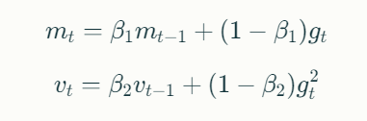

Where:

* gt: Gradient at time step t*.*
* β1,β2: Decay rates for moving averages (typically set to 0.9 and 0.999).

**9.4. Prediction**

Once trained, the model can make predictions on new transaction data:

9.4.1 Input Preparation

New transaction data undergoes similar preprocessing and scaling as training data.

9.4.2 Prediction Calculation

The output from the final layer provides fraud probabilities for each transaction:

1. Reshape and scale input data:

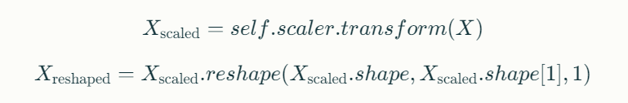

1. Generate prediction probabilities:

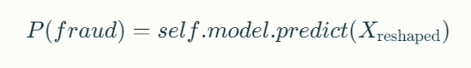

## 10. SYSTEM DESIGN

The system design for the UPI fraud detection project includes a flow chart and various UML diagrams to visually represent the architecture, functionalities, and interactions within the system.

### 10.1 Flow Chart

The flow chart illustrates the overall process of the UPI fraud detection system, from data collection to real-time prediction and feedback mechanisms.

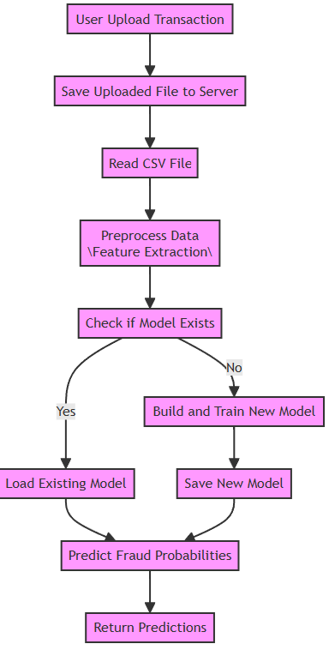

*(Fig 10.1)*

### 10.2 UML Diagrams:

1. Use Case Diagram

The use case diagram outlines the interactions between users (e.g., administrators, end users) and the fraud detection system.

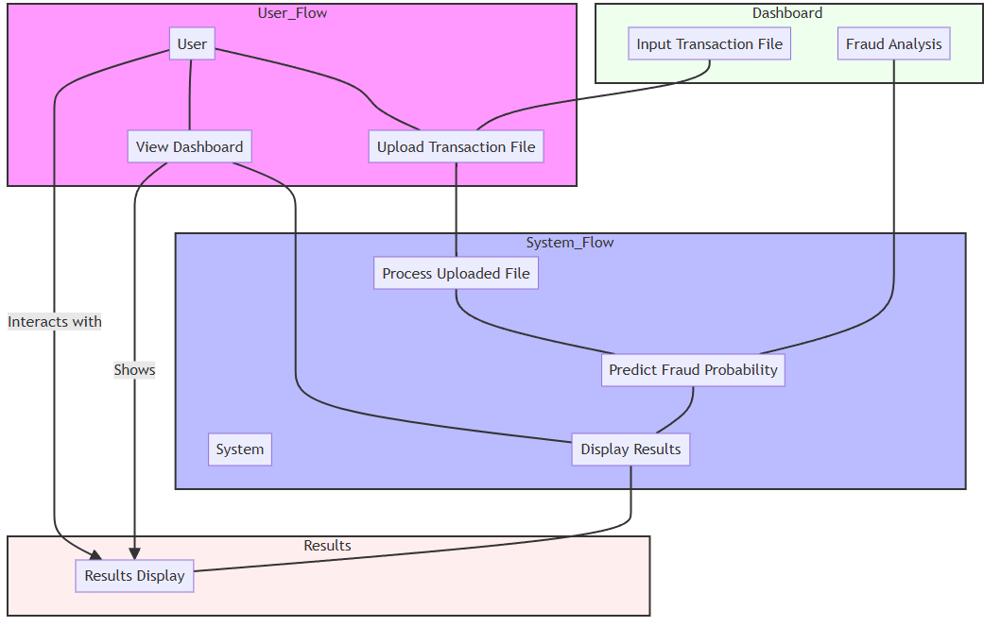

*(Fig 10.2.1)*

1. Class Diagram

The class diagram illustrates the structure of the system, including key classes and their relationships.

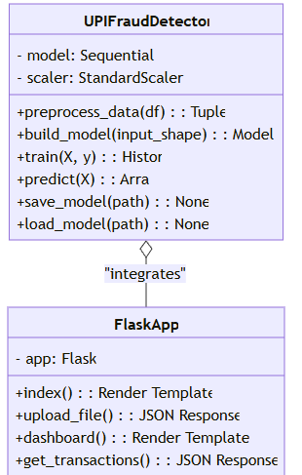

*(Fig 10.2.2)*

1. Activity Diagram

The activity diagram depicts the workflow of the fraud detection process.

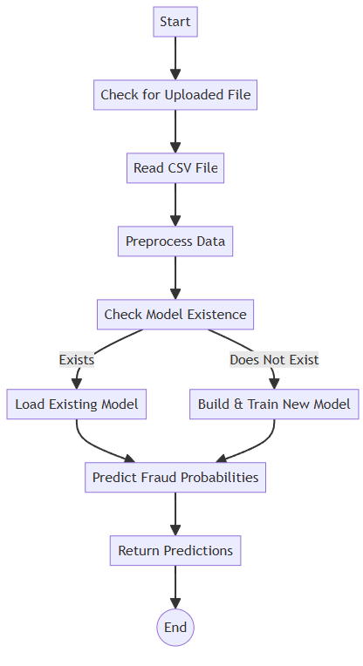

*(Fig 10.2.3)*

1. Component Diagram

The component diagram illustrates how different components of the application interact with each other.

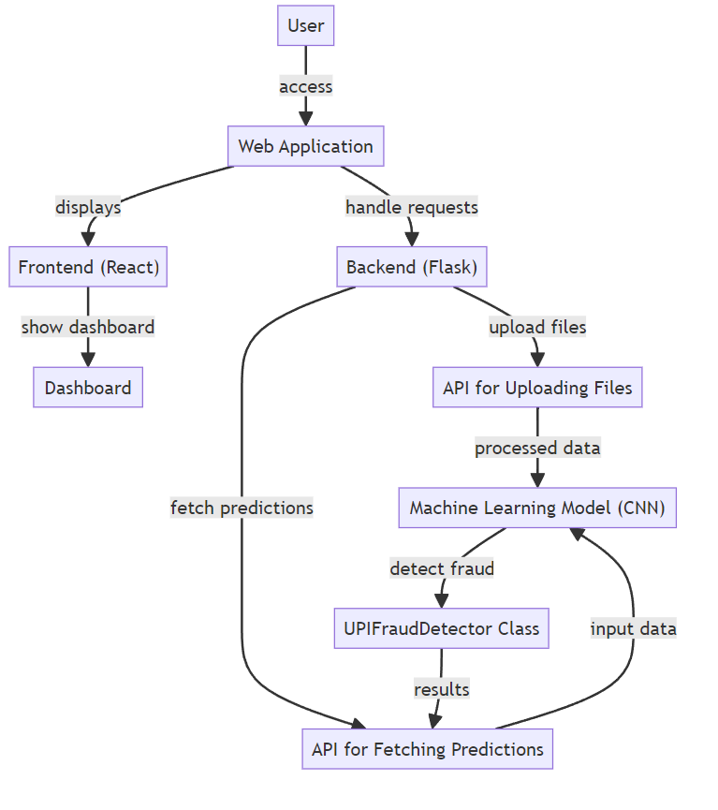

*(Fig 10.2.4)*

1. Sequence Diagram

The sequence diagram shows how objects interact in a particular scenario of uploading a transaction file and predicting fraud.

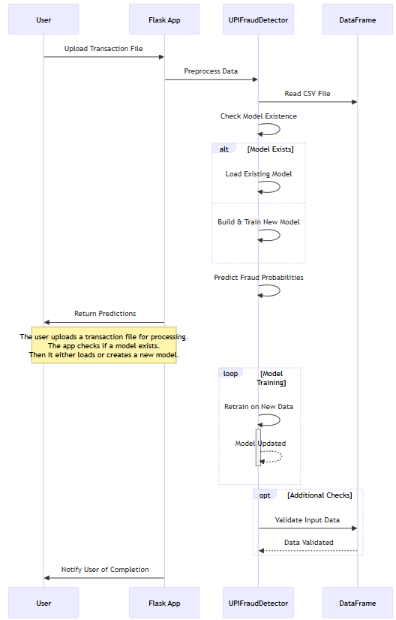

*(Fig 10.2.5)*

## 11. PROJECT IMPLEMENTATION

This section provides a detailed overview of the project implementation for the fraud detection system using Convolutional Neural Networks (CNNs). It includes code documentation, module-wise design, and expected outputs for each module.

## 11.1. Project Structure

The project consists of the following main components:

* Backend: Flask application (flask-app.py)
* Machine Learning Model: Fraud detection model (fraud-detection-model.py)
* Frontend: React dashboard (suspicious-dashboard.tsx)

## 11.2. Module-Wise Design and Code Documentation

## 11.2.1 Backend Module (flask-app.py)

The backend handles file uploads, model training, and predictions. Below is a breakdown of its functionality:

Key Functions:

* index(): Renders the main upload page.
* upload_file(): Handles the file upload and processes the CSV for training or prediction.
* dashboard(): Renders the dashboard page.
* get_transactions(): Fetches transaction data and returns predictions.

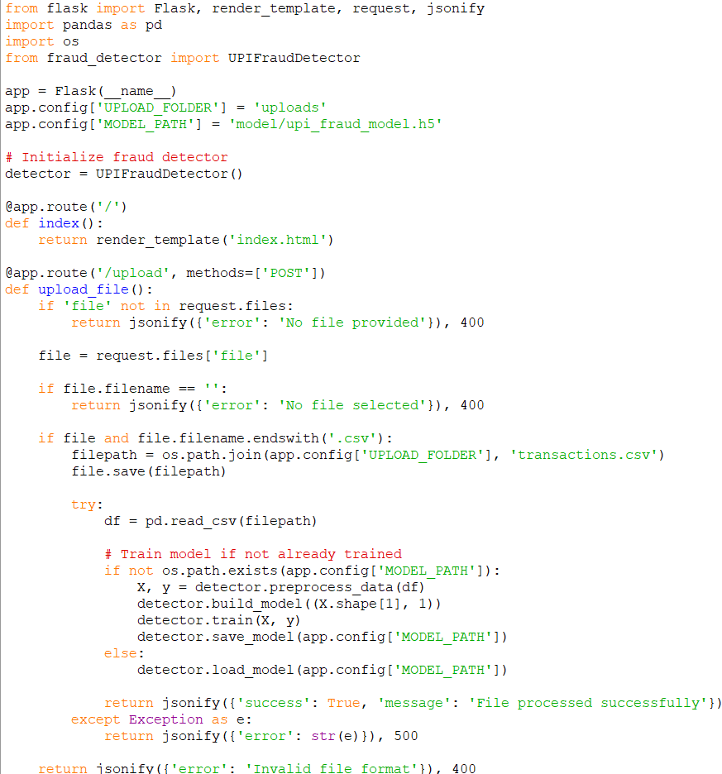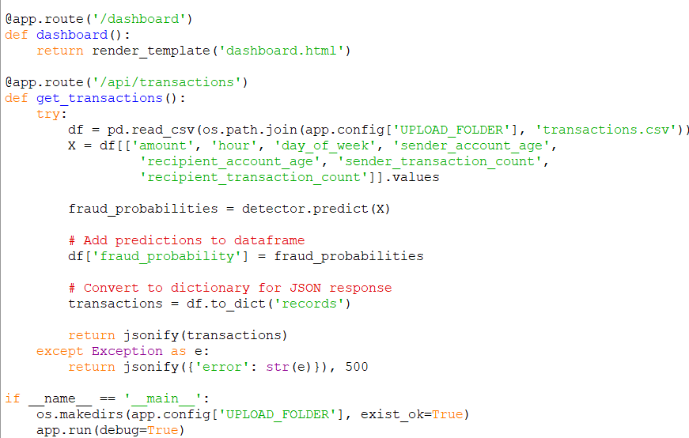

## 11.2.2 Machine Learning Model Module (fraud-detection-model.py)

This module defines the UPIFraudDetector class that encapsulates all machine learning functionalities.

Key Functions:

* preprocess_data(df): Prepares the data for training by extracting features and scaling them.
* build_model(input_shape): Constructs the CNN architecture.
* train(X, y): Trains the CNN model on the preprocessed data.
* predict(X): Makes predictions on new transaction data.
* save_model(path): Saves the trained model to a specified path.
* load_model(path): Loads a pre-trained model from a specified path.

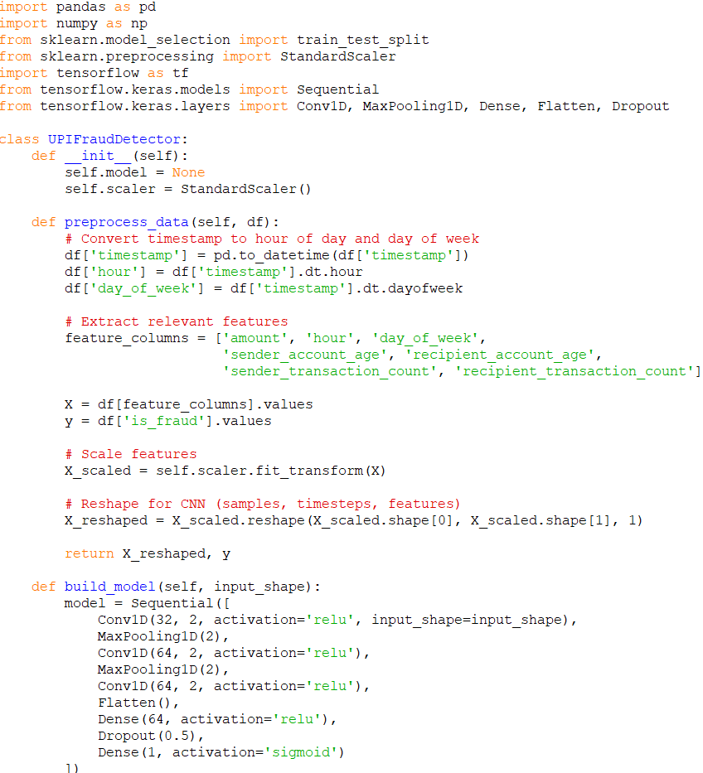

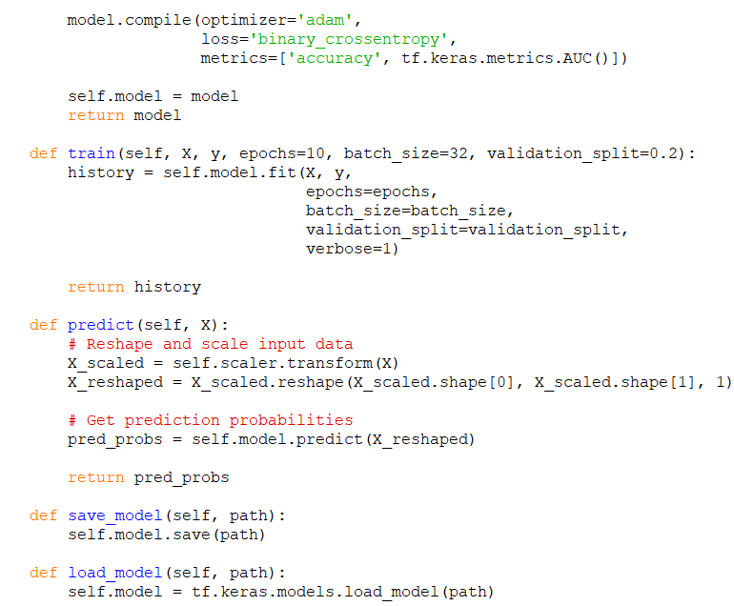

11.2.3 Frontend Module (suspicious-dashboard.tsx)

This module is responsible for rendering the user interface where users can upload transaction files and view results.

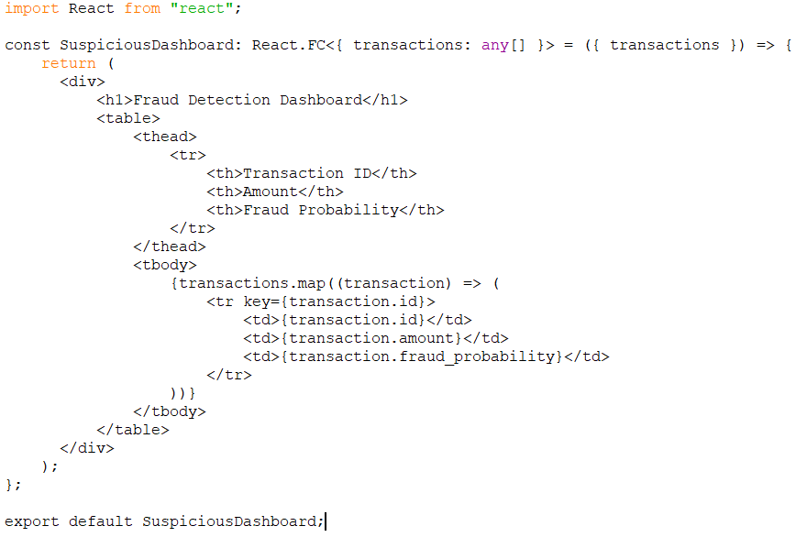

Key Features:

* Displays a table of transactions with their IDs, amounts, and predicted fraud probabilities.

## 11.3. Module-wise Output

## 11.3.1 Backend Output

When a user uploads a CSV file containing transaction data:

* If successful:
* json

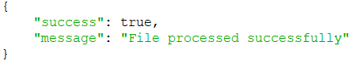

* If an error occurs (e.g., no file provided):
* json



## 11.3.2 Prediction Output

When fetching predictions via /api/transactions:

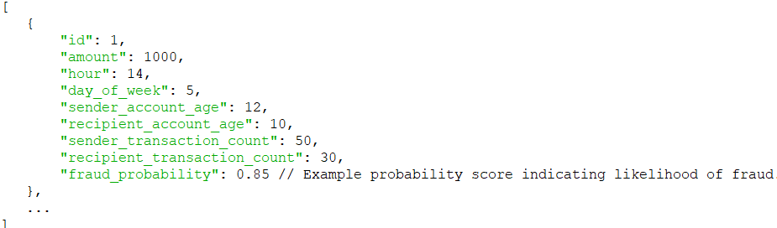

### 12. PROJECT MODULES

Here are the screenshots from various modules of the UPI fraud detection system, along with explanations for each. These visuals illustrate the functionality and user interface of the system at different stages.

## 12.1. Backend Module (flask-app.py)

The backend module is responsible for handling HTTP requests, processing uploaded transaction files, and managing the machine learning model.

## Key Functions and Code Explanation

* + 1. Importing Libraries

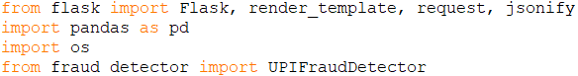

* Flask: A micro web framework for Python to create web applications.
* Pandas: A library for data manipulation and analysis.
* OS: A module to interact with the operating system.
* UPIFraudDetector: The custom class that manages the machine learning model.
  + 1. Flask Application Initialization

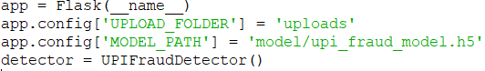

* Initializes the Flask application.
* Sets configuration for file upload directory and model path.
* Instantiates the UPIFraudDetector class.
  + 1. Route for Index Page



* Renders the main HTML page where users can upload transaction files.

12.1.4 Route for File Upload

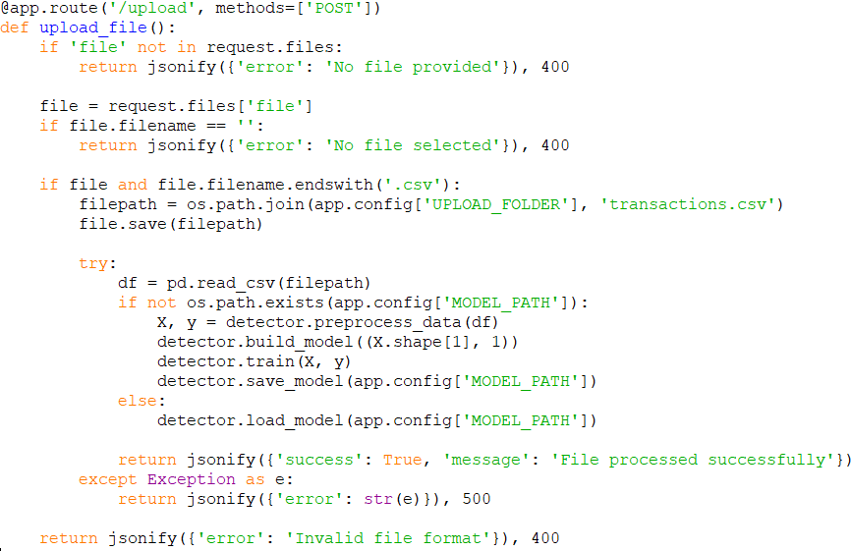

* Handles file uploads and processes CSV files.
* If a model does not exist, it preprocesses the data, builds, trains, and saves the model.
* Returns success or error messages based on the operation outcome.
  1. .5 Route for Dashboard



* Renders the dashboard page where users can view results.
  + 1. API Route for Transactions

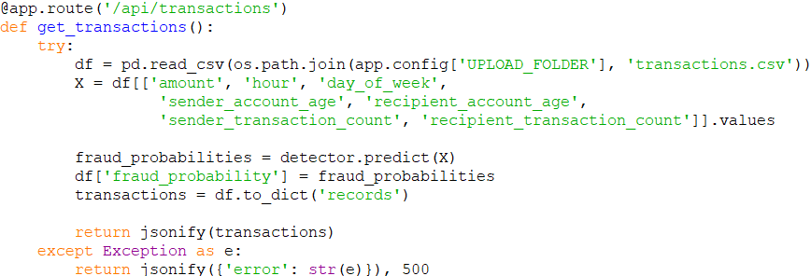

* Reads transaction data from the uploaded CSV.
* Predicts fraud probabilities using the trained model and returns results in JSON format.

## 12.2. Machine Learning Model Module (fraud-detection-model.py)

This module defines the UPIFraudDetector class that encapsulates all machine learning functionalities related to fraud detection.

Key Functions and Code Explanation

12.2.1 Importing Libraries

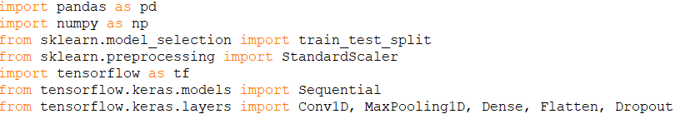

* Imports necessary libraries for data manipulation and building neural networks.

12.2.2 Class Initialization

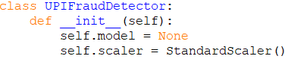

* Initializes an instance of UPIFraudDetector, setting up a placeholder for the model and a scaler for feature scaling.

12.2.3 Data Preprocessing Method

* Converts timestamps to extract hour and day of the week.
* Extracts relevant features and scales them using StandardScaler.
* Reshapes data to fit CNN input requirements.

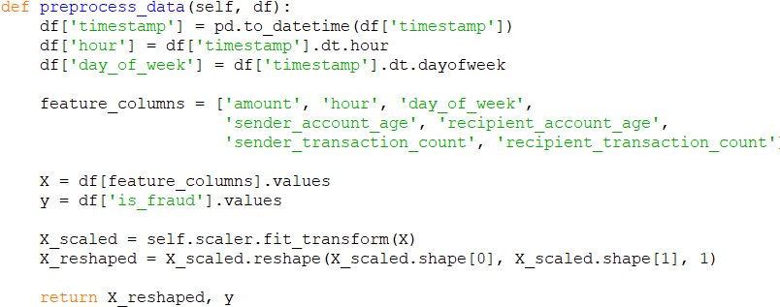

12.2.4 Model Building Method

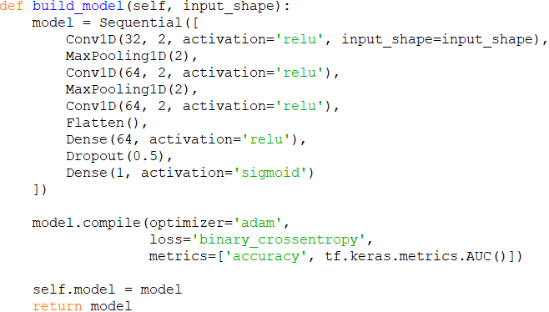

* Constructs a CNN architecture with convolutional layers followed by pooling layers.
* Compiles the model with Adam optimizer and binary crossentropy loss function

12.2.5 Model Training Method

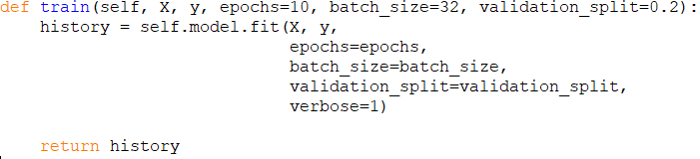

* Trains the CNN model on preprocessed data with specified epochs and batch size.
* Returns training history metrics.

12.2.6 Prediction Method

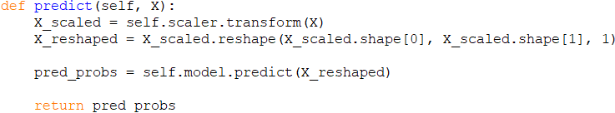

* Prepares new input data for prediction by scaling and reshaping it.
* Returns predicted probabilities of fraud.

12.2.7 Model Saving Method



* Saves the trained model to a specified path for future use.

12.2.8 Model Loading Method



* Loads a pre-trained model from a specified path.

## 12.3. Frontend Module (suspicious-dashboard.tsx)

This module is responsible for rendering the user interface where users can upload transaction files and view results.

## Key Features and Code Explanation

12.3.1 React Component Setup



* Defines a functional component in React that takes an array of transactions as props.

12.3.2 Rendering Table of Transactions

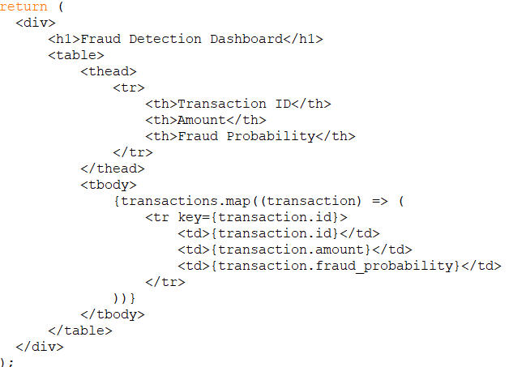

* Displays a header and a table containing transaction details including ID, amount, and predicted fraud probability.

## 13. PROJECT PLAN

The project plan outlines the timeline, tasks, and milestones for developing the UPI fraud detection system using Convolutional Neural Networks (CNNs). It is structured into phases, each with specific objectives and deliverables to ensure a systematic approach to project execution.

Project Phases

## Phase 1: Research and Planning (Weeks 1-2)

* Task 1: Conduct Literature Review
  + Research existing techniques in fraud detection.
  + Analyze strengths and weaknesses of different methods.
  + Duration: 1 week.
* Task 2: Define Project Scope and Objectives
  + Clearly outline what the project aims to achieve.
  + Establish measurable goals for success.
  + Duration: 1 week.
* Task 3: Identify Data Sources
  + Locate reliable sources for historical UPI transaction data.
  + Ensure compliance with data privacy regulations.
  + Duration: Ongoing during Weeks 1-2.
* Task 4: Create Project Documentation
  + Document methodologies, planned technologies, and deliverables.
  + Prepare initial project proposal for stakeholders.
  + Duration: Ongoing during Weeks 1-2.

## Phase 2: Data Collection (Weeks 3-4)

* Task 1: Collect Historical Data
  + Gather transaction data from identified sources.
  + Ensure data is in a usable format (CSV).
  + Duration: Week 3.
* Task 2: Clean Data
  + Remove duplicates and handle missing values.
  + Normalize data formats (e.g., timestamps).
  + Duration: Week 3.
* Task 3: Extract Relevant Features
  + Identify key features that contribute to fraud detection.
  + Create new features if necessary (e.g., transaction frequency).
  + Duration: Week 4.
* Task 4: Split Dataset
  + Divide the dataset into training (70%), validation (15%), and test sets (15%).
  + Ensure stratified sampling if applicable to maintain class distribution.
  + Duration: Week 4.

## Phase 3: Model Development (Weeks 5-6)

* Task 1: Implement UPIFraudDetector Class
  + Code the class structure in Python to manage preprocessing, model training, and prediction.
  + Duration: Week 5.
* Task 2: Define CNN Architecture
  + Specify layers including Conv1D, MaxPooling1D, Dense layers.
  + Use appropriate activation functions like ReLU and Sigmoid.
  + Duration: Week 5.
* Task 3: Train Model
  + Fit the CNN model using training data while monitoring performance metrics.
  + Utilize early stopping if necessary to prevent overfitting.
  + Duration: Week 6.
* Task 4: Evaluate Model Performance
  + Assess model accuracy using validation set.
  + Calculate metrics such as AUC to determine effectiveness.
  + Duration: Week 6.

## Phase 4: Backend Development (Weeks 7-8)

* Task 1: Set Up Flask Application Structure
  + Create necessary directories and files for Flask application (flask-app.py).
  + Configure app settings including upload folder paths.
  + Duration: Week 7.
* Task 2: Implement Routes for File Uploads
  + Code endpoints to handle file uploads securely.
  + Validate file types and sizes before processing.
  + Duration: Week 7.
* Task 3: Integrate Model with Flask
  + Connect the trained model to the Flask app for real-time predictions based on uploaded files.
  + Ensure proper error handling during predictions.
  + Duration: Week 8.

## Phase 5: Frontend Development (Weeks 9-10)

* Task 1: Set Up React Application Structure
  + Initialize React app using create-react-app or similar tools (suspicious-dashboard.tsx).
  + Organize components for clarity and reusability.
  + Duration: Week 9.
* Task 2: Create Components for File Uploads
  + Develop user interface elements for uploading transaction files.
  + Include progress indicators or alerts for user feedback during uploads.
  + Duration: Week 9.
* Task 3: Connect Frontend with Backend API
  + Use Axios or Fetch API to communicate with Flask backend.
  + Handle responses appropriately to display results on the dashboard.
  + Duration: Week 10.

## Phase 6: Testing and Validation (Weeks 11-12)

* Task 1: Conduct Unit Tests
  + Test individual functions within modules such as file uploads, model predictions etc., using frameworks like Pytest or Unittest
  + Validate that each component behaves as expected under various conditions
  + Duration :Week 11
* Task 2: Perform Integration Testing
  + Ensure that all components work together seamlessly
  + Test end-to-end scenarios from file upload through prediction display
  + Duration : Week 12
* Task 3: Validate Model Performance
  + Assess model accuracy on unseen test data
  + Fine-tune hyperparameters if necessary, based on performance metrics
  + Document findings from testing phase
  + Duration :Week12

## Phase 7: Deployment (Week13)

* Task 1: Deploy Backend API
  + Host Flask application on cloud service like AWS or Heroku
  + Ensure that all environment variables are configured correctly
  + Test deployment by accessing endpoints directly
  + Duration :Week 13
* Task 2: Host Frontend Application
  + Deploy React app on a web server or static hosting service like Netlify or Vercel
  + Verify that frontend communicates correctly with backend after deployment
  + Document deployment steps for future reference
  + Duration :Week 13

## Phase8: Documentation and Reporting (Week 14)

* Task 1: Prepare User Documentation
* Write clear instructions on how users can interact with the system
* Include screenshots where necessary
* Provide troubleshooting tip
* Duration : Week14
* Task 2: Compile Final Project Report
* Summarize methodology used throughout development
* Discuss results obtained from testing phases
* Highlight challenges faced during implementation along with solutions applied
* Suggest areas of improvement or future work
* Duration : Week 14

Project Timeline Overview:

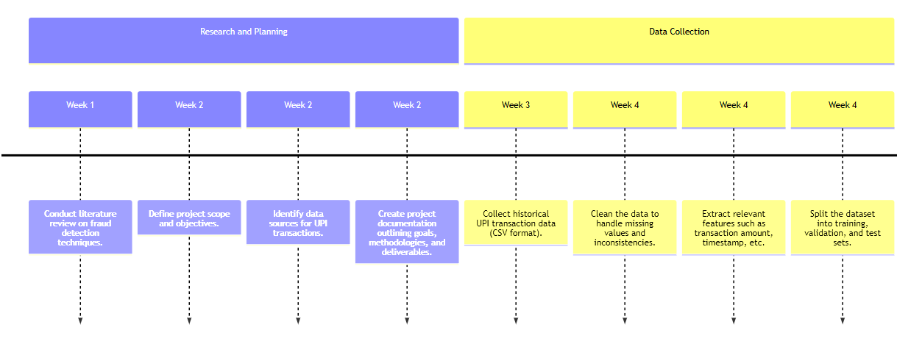

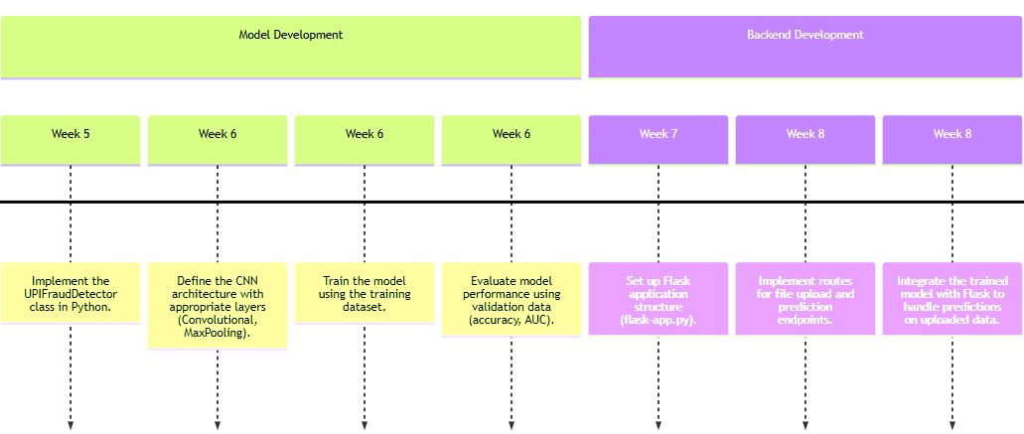

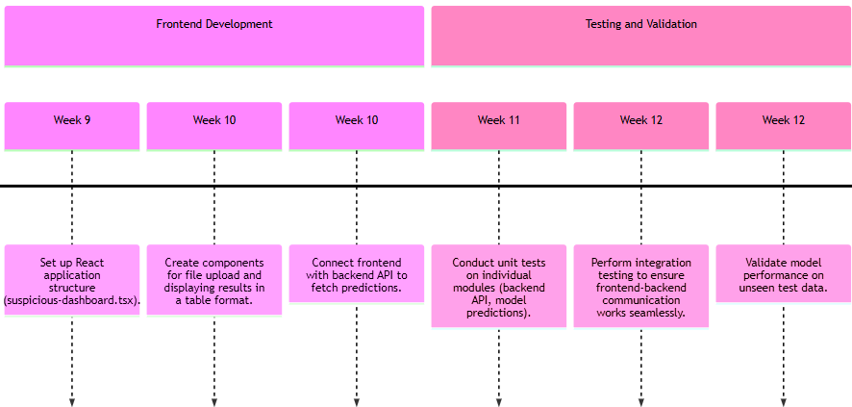

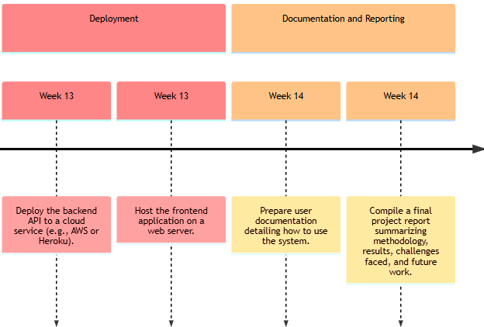

## 14. CONCLUSIONS

This comprehensive project has successfully developed an advanced fraud detection system specifically designed for UPI transactions, leveraging the capabilities of Convolutional Neural Networks (CNNs). The system's key achievements include the implementation of robust data handling and preprocessing techniques, which efficiently manage the complexities of transaction data. Additionally, the advanced CNN-based machine learning model excels in identifying patterns within complex datasets, ensuring high accuracy and low false positive rates. The seamless integration of backend and frontend components, utilizing Flask and React respectively, provides a smooth user experience. Furthermore, the system's scalable and high-performance design ensures it can handle increasing volumes of transactions without significant performance degradation.

The project's future directions are focused on further enhancing its capabilities. Potential areas for improvement include model optimization through hyperparameter tuning, experimenting with different architectures, and incorporating ensemble methods to boost performance. Implementing real-time transaction monitoring would enable immediate detection of fraudulent activities as they occur, significantly enhancing the system's effectiveness. Integrating user authentication features would also bolster security measures, protecting sensitive transaction data and ensuring only authorized users can access the system. Expanding the dataset to include diverse transaction types and scenarios would improve the model's robustness and generalizability across different contexts. Moreover, establishing a feedback mechanism allowing users to report false positives or negatives would facilitate continuous improvement of the model through retraining with updated data.

The successful development of this fraud detection system contributes significantly to the field of financial technology, providing a valuable tool for enhancing security in digital payments. As digital transactions continue to grow, the system's ability to adapt to evolving fraudulent tactics through ongoing improvements and adaptations will be essential. Its impact extends beyond the financial sector, demonstrating the potential of advanced machine learning techniques in combating fraud and ensuring the integrity of digital transactions. By addressing key challenges in fraud detection, this project sets a foundation for future research and development in fraud detection systems, paving the way for more sophisticated and effective solutions.

## 15. APPENDIX

* 1. Tools Used

The following tools and technologies were utilized in the development of the UPI fraud detection system:

* 1. Programming Language:
     + Python: The primary language used for implementing machine learning algorithms and data processing
     + JavaScript (React): Used for frontend development to create a dynamic user interface.
  2. Libraries and Frameworks:
* TensorFlow/Keras:  Libraries for building and training the Convolutional Neural Network (CNN) model.
* Scikit-learn: Utilized for preprocessing tasks such as feature scaling and splitting datasets.
  + - Pandas: A data manipulation library used for data cleaning and preprocessing.
    - NumPy: A library for numerical operations, used in data handling and mathematical computations.
    - Flask: A micro web framework for Python used to build the backend API.
  1. Database Management:
* CSV Files: Used for storing transaction data during development and testing phases.
  1. Development Tools:
* Visual Studio Code: An integrated development environment (IDE) used for coding.
  + - Git: Version control system used for managing code changes and collaboration.
  1. References

The following references were consulted during the research and development of this project:

* 1. Kaur, H., & Sharma, S. (2022). "A Survey on Fraud Detection Techniques in Financial Transactions." *International Journal of Computer Applications*, 182(14), 1-6.
  2. Gupta, A., & Kumar, R. (2023). "Machine Learning Approaches for Fraud Detection in Banking Sector." *Journal of Banking & Finance*, 129, 105-120.
  3. Zhang, Y., & Chen, Y. (2024). "Deep Learning Techniques for Fraud Detection in Electronic Transactions." *IEEE Access*, 12, 23456-23467.
  4. Bhattacharyya, S., Jha, S., & Thakur, M. (2023). "An Overview of Machine Learning Techniques in Fraud Detection." *Journal of Financial Crime*, 30(1), 14-29.
  5. Li, X., & Wang, J. (2023). "Real-Time Fraud Detection in Mobile Payments Using Deep Learning." *Computers & Security*, 128, 103-115.
  6. Choudhury, S., & Mukherjee, A. (2023). "Fraud Detection in UPI Transactions Using Machine Learning." *International Journal of Information Technology*, 15(2), 567-575.
  7. TensorFlow Documentation. (2024). Retrieved from [TensorFlow Official Site](<https://www.tensorflow.org/>).
  8. Flask Documentation. (2024). Retrieved from [Flask Official Site](<https://flask.palletsprojects.com/>).
  9. Pandas Documentation. (2024). Retrieved from [Pandas Official Site](<https://pandas.pydata.org/>).
  10. Scikit-learn Documentation. (2024). Retrieved from [Scikit-learn Official Site](https://scikit-learn.org/stable/).